Chapter 4

DESIGN OF THE PROTOTYPE

The User Interface

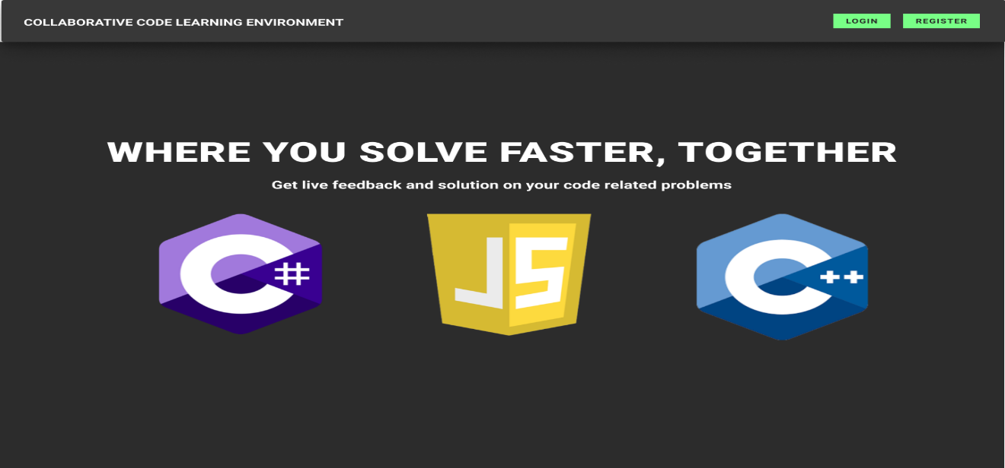

Figure 18. Home Page UI

Description: This form is used to view the home page

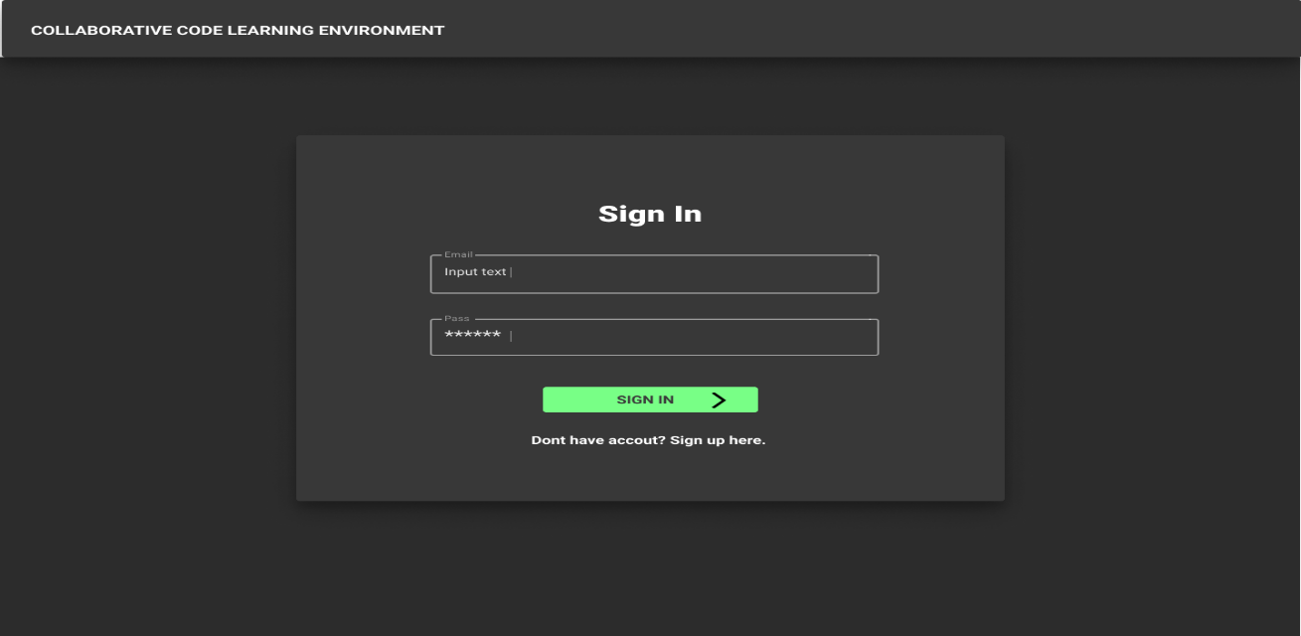

Figure 19. User Authentication UI

Description: This form is used to log-in the user account.

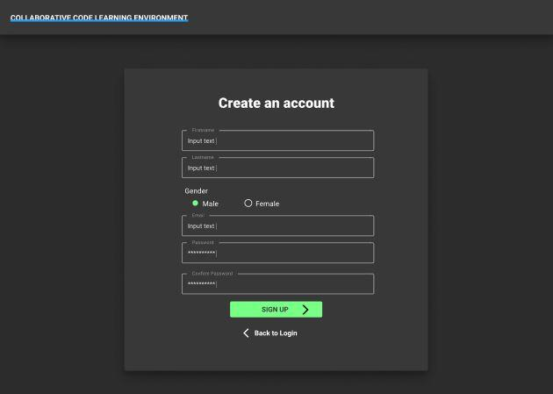

Figure 20. Sign Up IU

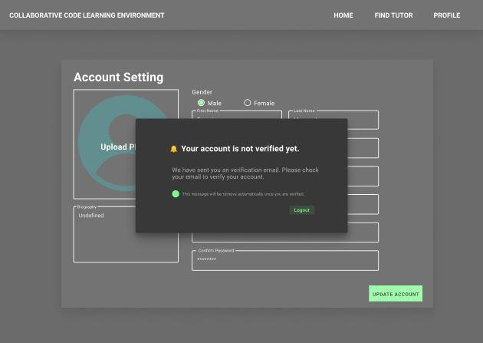Description: This form is used to create an account.

Figure 21. Verification Alert UI

Description: This form is used to alert the user to verify the account.

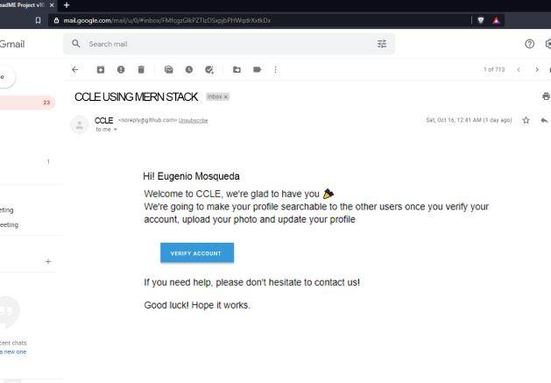

Figure 22. Account Verification UI

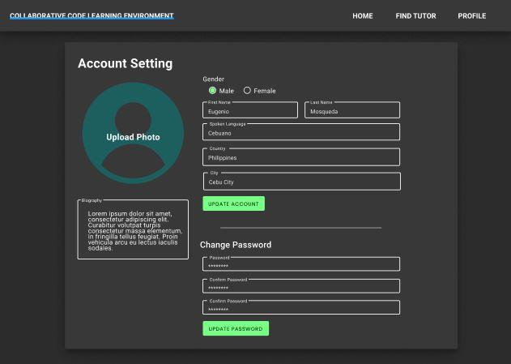Description: This form is used to verify the account.

Figure 23. Account Setting UI

Description: This form is to modify your account.

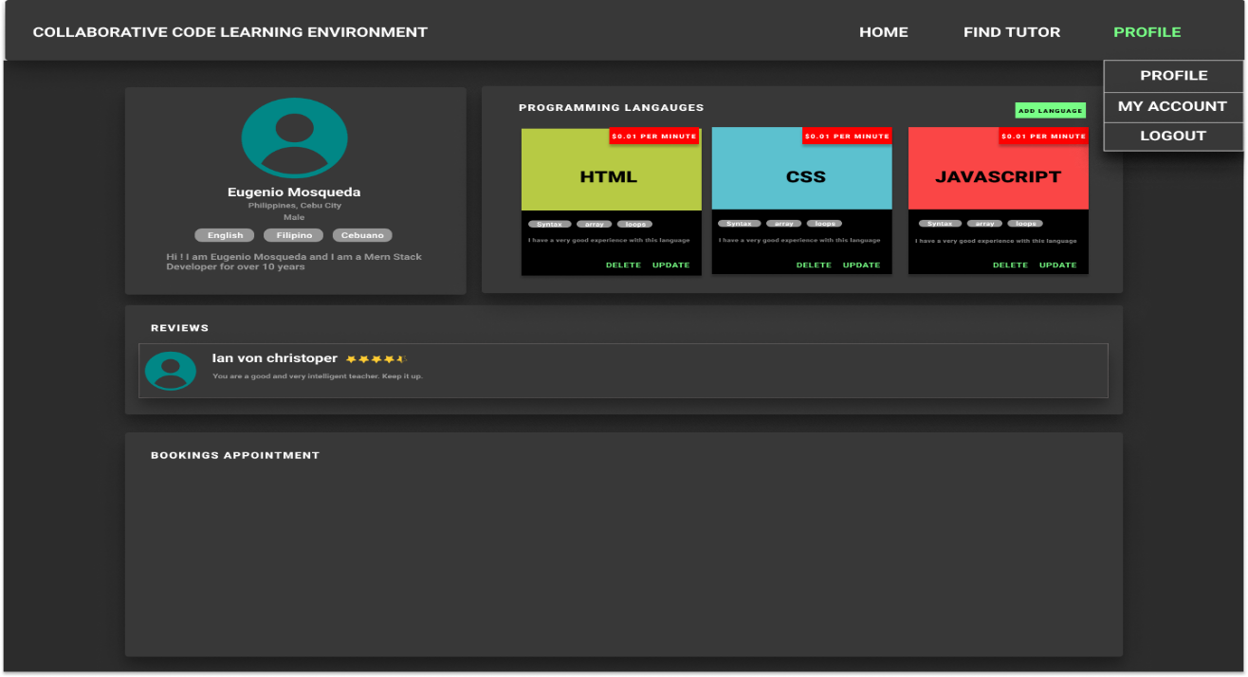

Figure 24. User Profile UI

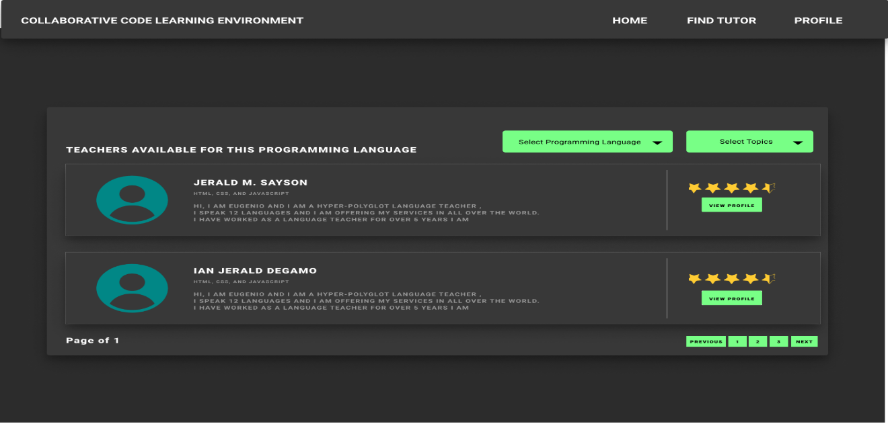Description: This form is to view and navigate user profile

Figure 25. Find Tutor UI

Description: This form is to select and search tutor.

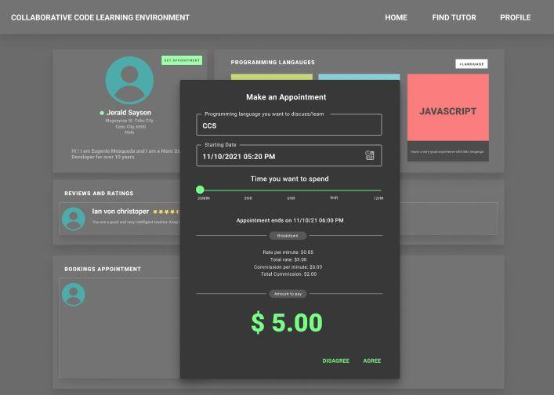

Figure 26. Set Appointment UI

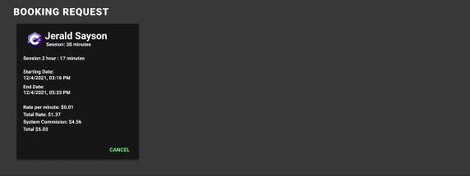Description: This form is to set appointment.

Figure 27. Booking Request UI

Description: This form is to view the booking request.

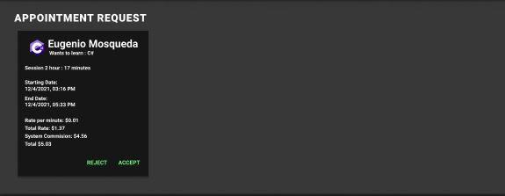

Figure 28. Accept booking request UI

Description: This form is to accept booking request.

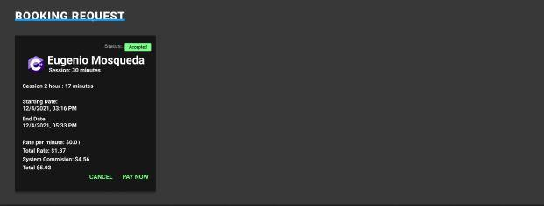

Figure 29. Payment booking UI

Description: This form is to pay the appointment.

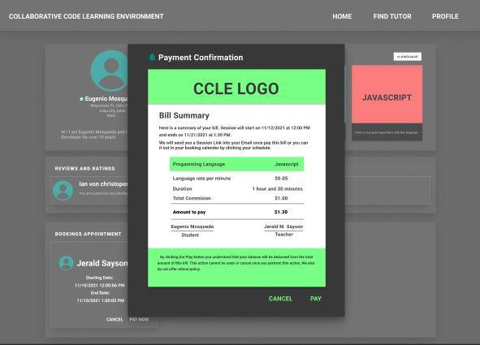

Figure 30. Bill receipt UI

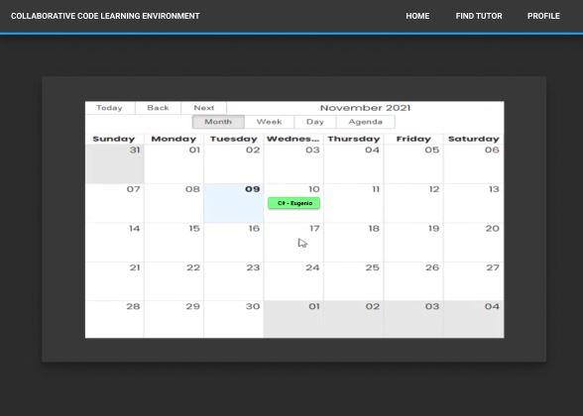Description: This form is to view and to pay the bill receipt

Figure 31. Appointment Calendar UI

Description: This form is to view appointments.

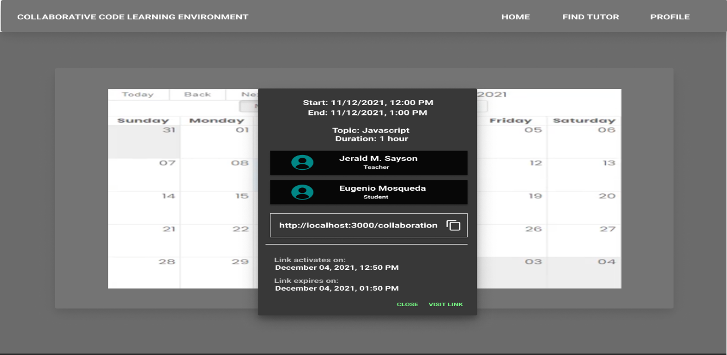

Figure 32. Access link UI

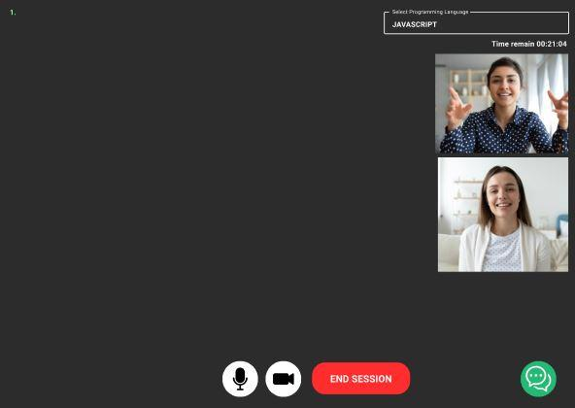Description: This form is to access the link for collaboration.

Figure 33. Video and Code Collaboration UI

Description: This form is to collaborate video and code.